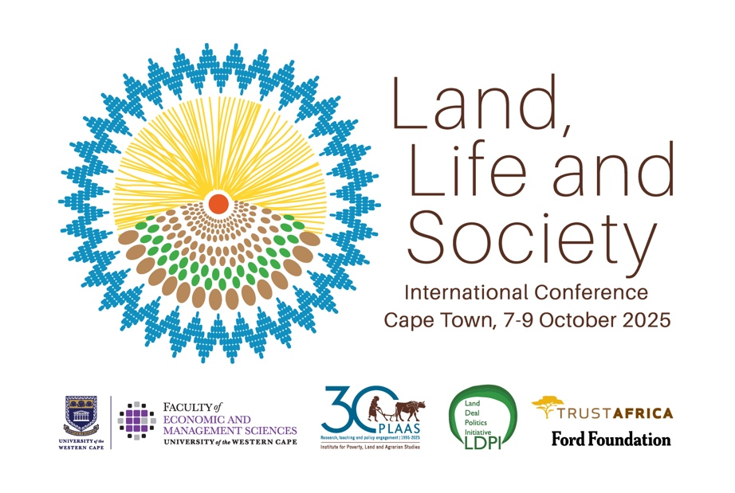
Disclaimer: these are notes taken by rapporteurs who have done their best to capture the statements and arguments of the presenters accurately. There may well be errors. This text should not be cited without checking with the authors and presenters concerned.

Day Two Conference Proceedings – Summary
8 October 2025
Day 2 of ICARRD deepened debates on land redistribution, environmental justice, food systems, and the intersections between climate, gender, and governance. Across sessions, a central theme emerged: the crisis of development and the search for alternative, justice-centered frameworks that reconnect land, livelihood, and democracy.
Land Redistribution and Justice
Plenary discussions called for redefining redistribution beyond property transfer toward restitution, recognition, and decolonization. Speakers from India, South Africa, Brazil, and Namibia converged on the idea that redistribution must confront intersecting systems of race, class, caste, and gender. While Ben Cousins emphasized the absence of a coherent theory of organization on the Left, others like Rahma Hassan and Carmen Louw underscored community agency and women’s struggles as central to agrarian transformation. The debate on why redistribution remains politically difficult pointed to elite capture, weak movements, and the state’s complicity with agrarian capital.
Extractivism, Commons, and Resistance
Panels on land grabbing, mining, and conservation revealed a recurring pattern: development framed through extractivism, dispossession, and enclosure. Case studies from South Africa’s Wild Coast and platinum belt illustrated grassroots defiance against mining and corporate-led “development.” The tension between communal consent and state-backed megaprojects foregrounded a broader question—whose development counts? Similarly, pastoral and blue justice panels exposed how “green” and “blue” economies reproduce colonial spatial injustices through conservation and carbon markets.

Climate, Food, and the Political Economy of Sustainability
Sessions on food sovereignty and climate finance critiqued the capture of sustainability by corporate and financial interests. Scholars and activists argued that “climate-smart” and market-led solutions perpetuate inequality, sidelining smallholders and women farmers. Agroecology, indigenous food systems, and informal food markets were presented as radical alternatives, rooted in local knowledge, equity, and ecological ethics. The call for a “One Food Approach” tied urban agriculture, informal markets, and peri-urban farming to the struggle for social and environmental justice.

Thematic Crosscurrents and Emerging Debates:
A critical convergence emerged around five key themes:
- Redistribution as Repair: Land reform as restitution, recognition, and decolonization, not mere asset transfer.
- Commons and Resistance: Reclaiming communal governance against commodification of land, water, and carbon.
- Gender and Generation: Women’s and youth struggles as the vanguard of agrarian and ecological justice.
- Climate Justice Beyond Markets: Critiques of carbon finance and green extractivism reframed climate solutions as reparative, not transactional.
- Building Counter-Power: Movements must bridge rural-urban, local-global, and class divides to forge collective strategies.

The Road to ICARRD 2026
Discussions on the way forward emphasized the need to rebuild a radical, transnational agrarian movement grounded in solidarity, feminist praxis, and climate justice. Future agendas must move beyond critique to praxis: linking redistribution to ecological repair, food sovereignty, and democratic control of land and resources. As several speakers concluded, agrarian reform itself is a climate solution. ICARRD 2026 must therefore articulate a unified political project—centering people, commons, and planetary survival over profit, and building a renewed vision of justice that is as ecological as it is social.

