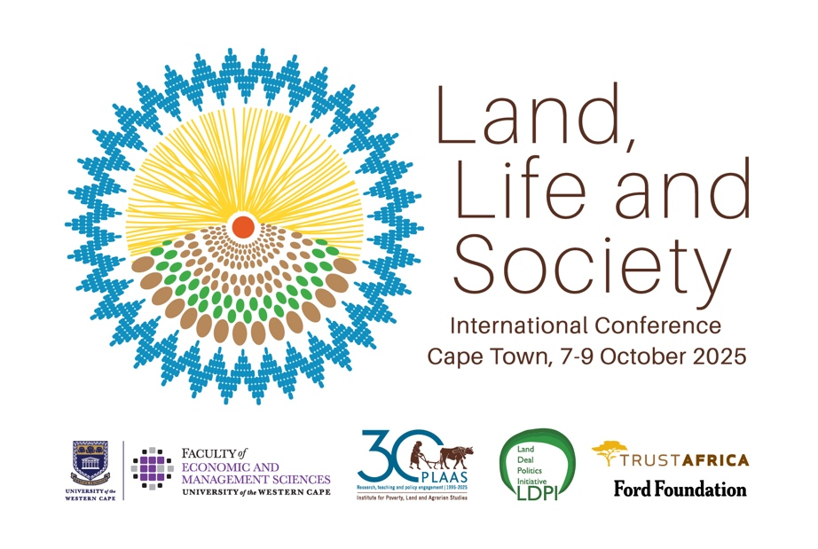
Disclaimer: these are notes taken by rapporteurs who have done their best to capture the statements and arguments of the presenters accurately. There may well be errors. This text should not be cited without checking with the authors and presenters concerned.

Day three Conference Proceedings – Summary
9 October 2025
Discussions across plenaries and panels underscored how struggles over land, water, food, and nature are deeply interconnected, shaped by colonial legacies, neoliberalism, and contemporary extractivism. A central theme was the call to reclaim commons whether in fisheries, agriculture, forests, or urban spaces through justice-oriented frameworks that prioritize community control, dignity, and ecological sustainability.
Oceans and water plenary
Speakers highlighted how “blue economy” agendas replicate extractive logics, marginalizing small-scale fishers and indigenous communities. Justice was framed as not just about access but about rights to control and govern, with commons-based governance and co-produced knowledge as alternatives. Similarly, water politics were shown to cut across food, land, and climate, demanding holistic and decolonial governance.
Popular struggles and agrarian change
Debates highlighted the continuities between colonial dispossession and contemporary land grabbing, often advanced through conservation, corporate investment, and state complicity. Case studies from Zimbabwe, Namibia, Mozambique, and South Africa revealed both the persistence of elite capture and the rise of grassroots mobilization—ranging from women’s assemblies to youth land occupations. A key debate was whether state institutions can be reliable allies or whether they primarily entrench dispossession.
The agrarian question was revisited through cases in Brazil, Malawi, and Zimbabwe, with participants urging an “eco-agrarian” lens that integrates land, ecology, and livelihoods. The notion of “rural stayers” in Zimbabwe challenged assumptions about agrarian subjects, while debates stressed that today’s agrarian transitions must grapple with green grabbing, climate change, and hybrid livelihoods, not just land and labour.
Tenure and formalisation
Legalistic fixes such as titling or state landlordism often deepen exclusion, while community-based forms of governance provide more secure and equitable outcomes. Across contexts, from Tanzania to Ethiopia and South Africa, participants argued that reform must centre lived realities, commons, and collective tenure, rather than imposing bureaucratic or market-driven solutions.
Conflict, resistance, and environmental justice
Climate and conservation projects reproduce colonial patterns and corporate capture. The “spectacle” of climate action was critiqued for masking dispossession, while local resistances in Botswana, Ghana, and Casamance demonstrated both the power and challenges of defending land and nature. The debate emphasized the need for participatory, justice-driven approaches and protection of environmental defenders.
Food
Across multiple sessions, food sovereignty and seed systems emerged as sites of feminist and decolonial struggle, where women’s practices of saving and sharing seeds embody cultural survival and resistance. Informal food markets were highlighted as crucial nodes of redistribution and justice, countering corporate concentration.
Closing plenary on the road to ICCARD 2026
Crystallised a central tension: the need to name capitalism and imperialism as structural drivers of dispossession, while also working pragmatically within multilateral spaces to secure gains. The debates converged on the importance of building alliances across movements, states, and scholars, recognizing that genuine transformation is a long-term process rooted in local struggles but requiring global solidarity.
The day’s debates called for reclaiming commons, confronting extractivism, and reimagining governance from below anchored in feminist, ecological, and decolonial visions of justice.

