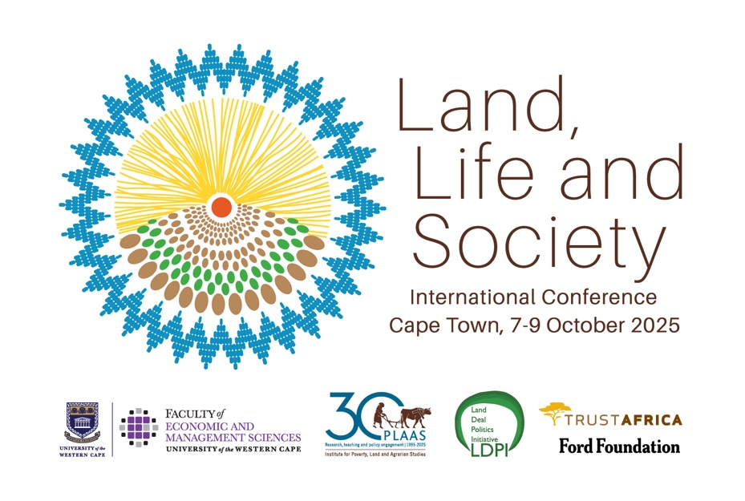

Day One Conference Proceedings – Summary
7 October 2025
Disclaimer: these are notes taken by rapporteurs who have done their best to capture the statements and arguments of the presenters accurately. There may well be errors. This text should not be cited without checking with the authors and presenters concerned.
Land
Speakers highlighted that land remains deeply tied to histories of dispossession, exclusion, and inequality. A key argument was made for moving beyond private, market-driven approaches toward common control of land and resources, recognising them as collective responsibilities rather than commodities. Across Africa, Asia, and Latin America, land alienation continues under new forms of extraction—carbon markets, large-scale land grabs, and corporate industrial farming. Alternatives must prioritize securing tenure rights, defending commons, and advancing land redistribution and restoration as matters of justice, equity, and sustainability.
Food
Food systems were described as highly unequal, shaped by monopoly power, corporate concentration, and market failures. Global governance, such as the G20, has struggled to balance growth, equity, and ecology. Discussions of food sovereignty emphasised six pillars: the right to healthy and culturally appropriate food, valuing producers, building local food systems, empowering communities, and advancing agroecology. Emerging technologies like cellular agriculture were presented as both opportunities and risks, raising critical questions about who controls innovation and how marginalized groups can benefit.
Politics
Land, food, and climate struggles were framed as political and moral questions demanding cooperation across borders. Democracy, participants argued, is incomplete until it addresses material inequalities in how land and resources are distributed. Global political economy debates connected dispossession with corporate-state alliances and new digital enclosures, such as agricultural data collection. Movements like La Vía Campesina were celebrated for defending peasant and working-class voices and challenging the dominance of capital in global agrarian governance.
Climate and Environment
Climate change was identified as a central driver of overlapping crises. The “green transition,” if led by corporate logics, risks creating new victims through carbon trading schemes, land grabs for renewable energy, and extractive “solutions.” Accumulation by extraction was identified as a defining feature of global capitalism today, demanding alternative ecological models. Participants stressed that small-scale producers, indigenous communities, and peasants are the true custodians of land and biodiversity, whose practices sustain ecological balance.
Water and Oceans
Beyond land, oceans and water systems are also under pressure from privatization, extractive industries, and state neglect. The struggles of fishers and coastal communities were recognised as central to agrarian justice. Protecting oceans and water as commons is critical to food sovereignty, climate resilience, and the survival of millions who depend directly on these resources.
Resistance and Alliance Building
The conference underscored the importance of alliances between rural and urban communities, women, youth, workers, peasants, and indigenous peoples. Knowledge and activism must work together, bridging local struggles with global solidarity. Preparations for ICARRD 2026 in Cartagena were framed as a pivotal moment to connect evidence with political struggle. Resistance to authoritarianism, corporate capture, and extractivism was seen as inseparable from building emancipatory alternatives grounded in democracy, justice, and sustainability.

